Practical Work document – Session 3
TABLE SYNTHESIS AND GRAPHICAL REPRESENTATION

Exercise 1 (individual work to be carried out during the course)
Context:
The HR department of a large company, noted A, carried out a study among 45 employees belonging to different departments and having different activities and/or level of responsibility within the company. Indeed, the HR department was particularly interested in the following variables:
- The gender of the employee (two modalities: H (for men) and F (for women))
- The number of dependent children of the employee
- The employee's level of education (modalities: B (for « bac » or less), L (for License), MD (pour Master or PHD)
- The net salary (after tax reduction and contributions) paid to the employee
The data (in the raw state) of each variable studied, are accessible via Moodle in the section dedicated to session 3 (file "PW-Session 3".xlsx Sheet entitled: Company A)

Mission 1.1 :
After carefully reading Appendix 1, Appendix 2 and Appendix 4, students are encouraged to:
- Calculate the number of data
- Complete the Tables 1, 2 and 3
- Graphically represent the data associated with the variables Gender / Level of education / Number of children (be careful to choose the appropriate graphical tool, i.e. according to the nature of each variable)
- Draw the curve of the increasing cumulative frequencies associated with the data in the number of children variable.

Mission Objective:
- Summarize in a table the data (initially presented in the raw state) of a qualitative variable (nominal and/or ordinal)
- Summarize in a table the data (initially presented in the raw state) of a discrete quantitative variable.
- Perform basic operations on the synthesized results (i.e. increasing cumulative number and increasing cumulative frequency)
- Choose the right graphical tool to represent the data according to its nature.
- Draw and interpret graphical representations of data
Mission 1.2 :
After a careful reading of Appendix 2, Appendix 3 and Appendix 4, students are required to:
- Complete Table 4.
- Use Table 4 to graphically represent the data for the salary variable
- Draw the curve of the increasing cumulative frequencies associated with the data for the salary variable.
Mission Objective:
- Synthesize in a table the data (initially presented in the raw state) of a continuous quantitative variable (where the modalities / classes are predefined)
- Perform basic operations on the synthesized results (i.e. increasing cumulative number and increasing cumulative frequency)
- Choose the right graphical tool to represent the data according to its nature.
- Draw and interpret graphical representations of data

To go further :
The Pivot Tables can be used to calculate the numbers (ni) in tables 1, 2 and 3. Apply the concepts studied during the Excel getting started sessions and create pivot tables in professional format and in consistence with the format of tables 1, 2 and 3 (styles, change of title, sorting etc ...).

Exercise 2 (individual work to be carried out outside the course)
Context:
The HR department of a large company, noted B, carried out a study among 50 employees belonging to different departments and having different activities and/or level of responsibility within the company. Indeed, the HR department was particularly interested in the following variables:
- The gender of the employee (two modalities: H (for men) and F (for women))
- The number of dependent children of the employee
- The employee's level of education (modalities: B (for « bac » or less), L (for License), MD (pour Master or PHD)
- The net salary (after tax reduction and contributions) paid to the employee
The data (in the raw state) of each variable studied, are accessible via Moodle in the section dedicated to session 3 (file "PW-Session 3".xlsx Sheet entitled: Company B)

Missions :
Apply all the missions of Exercise 1 on the data of Exercise 2.

Appendix 1: The function COUNTIF
First: the function COUNT and COUNTA are useful to count the number of elements. If the data are values/numbers, it is necessary to use the function COUNT. If the data are words/letters, it is necessary to use the function COUNTA.
The COUNTIF function is predefined in Excel and it allows you to count the number of cells that satisfy a criterion.
The COUNTIF function has two parameters:
- Range: the cells in which the count is made.
- Criteria: the condition that determines which cell will be taken into account in the count. This condition must be enclosed in quotation marks.
Practical examples:
- COUNTIF(A5 :A30 ; "95") in the range from A5 to A30, the function is used to count the number of cells whose value is equal to 95.
- COUNTIF (A5 :A30 ; "Jean") in the range from A5 to A30, the function counts the number of cells that contain the exact text "Jean".
- COUNTIF (A5 :A30 ; "< 100") in the range from A5 to A30, the function is used to count the number of cells that contain a number strictly less than 100.
- COUNTIF (A5 :A30 ; ">= 100") in the range from A5 to A30, the function is used to count the number of cells that contain a number greater than or equal to 100.
- COUNTIF (A5 :A30 ; "<> 100") in the range from A5 to A30, the function is used to count the number of cells that contain a number other than 100.
Appendix 2: Cumulative Sum
The purpose of the cumulative sum is to accumulate numerical data. This operation allows, for example, to show the evolution of a trend, such as following the evolution of the turnover of a company quarter by quarter.
There are several methods/techniques that allow you to perform a cumulative sum via Excel. In the following, we will present a simple method through an example.
We want to make the cumulative sum of the turnover of a company to examine the evolution over the four quarters of last year.

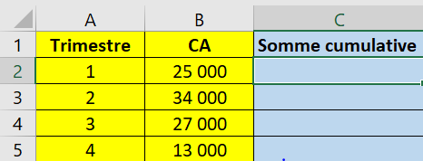

In the cell C2 write =B2. To view the first accumulation
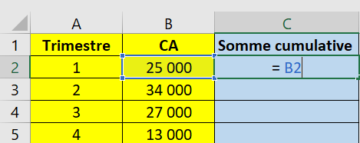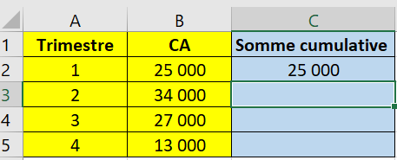
Then in the cell C3 write =B3+C2 and validate. The second cumulation adds the first cumulation containing in cell C2 to the value of the second cell B3.
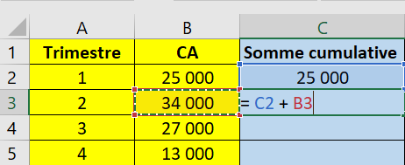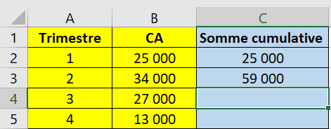

Finally, copy and paste the previous formula in the rest of the cells of the column
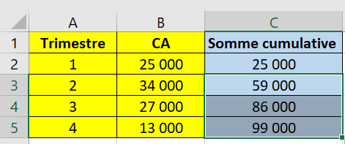
Appendix 3: the function COUNTIFS
The function COUNTIFS is predefined in Excel and allows you to count the number of cells that meet several criteria on the same range or on several different ranges.
La structure de la fonction est comme suit :
=COUNTIFS(criteria_range1 ; criteria1; criteria_range2; range2; criteria_range3 ; ...)
''criteria_range1, criteria_range2, criteria_range3, etc.'' represents the ranges of cells to count.
''criteria1, criteria2, etc.'' corresponds to the criteria that the value of the cell in the range corresponding to the criteria must meet in order to be counted.
As with the function COUNTIF the criteria must be in quotation marks.

Practical examples:

Suppose that the range A5:A30 corresponds to the first names of the candidates in a competition and the range B5 :B30 corresponds to the age of the candidates.

- COUNTIFS (A5 :A30 ; "Jeremy" ; A5 :A30 ; "Paul" ) in the range from A5 to A30, the function counts the number of cells that contain the exact text "Jeremy" and the exact text "Paul". In other words, the total number of candidates whose first name is Paul and/or Jeremy.

- COUNTIFS (A5 :A30 ; "Jeremy" ; B5 :B30 ; "> 35" ) in the range from A5 to A30, the function allows you to count the number of cells that contain the exact text "Jeremy" and on the range from B5 to B30, the function allows you to count the number of cells that contain a number strictly greater than 35. In other words, the total number of candidates whose first name is Jeremy and the age is strictly over 35 years.

Appendix 4 : The main graphical representations via Excel
The pie chart
In this section, we detail the steps you need to take to create a pie chart.
- Select the part of the table you want to turn into a chart, then click "Insert" in the top bar of Excel
- Click on the part to select the "pie" charts. For example, choose "3D pie"
- Explore chart options for better formatting (title/colors/labels/...)
The column/Bar Chart (Cylindric Bar Chart)
In this section, we detail the steps you need to take to create a cylindric bar chart.
- Select the part of the table you want to turn into a chart, then click "Insert" in the top bar of Excel
- Click on the part to select the charts "a histogram or a bar chart". Choose for example "2D Column" (you will build a graph with simple vertical bars) or "2D Bar" (you will build a graph with simple columns bars)
- Explore chart options for better formatting (title/colors/labels/...)
The Bar Chart
In this section, we detail the steps to follow to create a bar diagram
- Select the column associated with the numbers (or frequencies)
- Click on the part to select the charts Recommended Chart Choose All Charts/ Column Chart (you will build a graph with simple vertical bars)
- By convention, Excel will number the bars / sticks: 1, 2, 3, ... If these numbers (by default) do not correspond to the modalities of the variable studied, then they must be modified by following the following steps:

      - Click on "The funnel" 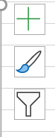located to the right of the graph and then on "select data"
      - In the "labels of the horizontal axis" section, click on modify and then assign to the abscissa the range that corresponds to the modalities of the variable studied.

- To make the difference with the previous cylindric chart we are led to reduce the width of the bars (just click on one of the bars to get to the formatting and then put the value of the width of the interval to the maximum)
- Explore chart options for better formatting (title/colors/labels/...)
- To add an arrow to the axes (just double click on the graph to get to the area dedicated to the formatting. Then select the axis you wish to modify in the "Format Axis" menu and then choose your options (color / thickness / type of final arrow /...)

The Histogram

In this section, we detail the steps you need to take to create the histogram. However, we distinguish three cases:

Case 1: The data is in its raw state.

Start by selecting the data column.
Click on the part to select the charts "insert a statistical chart" choose from the menu "Histogram"
Explore chart options for better formatting (title/colors/labels/...)
Note that with this approach, Excel will automatically select the modalities / classes (this selection is based on a theoretical background) Moreover, you will find that the selected classes have the same width.

Case 2: the data are synthesized in a table where the modalities / classes have the same width.

Select the column associated with the numbers (or frequencies)

Click on the part to select the charts "a histogram or a bar chart". Choose "2D Histogram" (you will build a graph with simple vertical bars)
Click on one of the bars to get to the formatting and then set the value of the width of the interval to the minimum the paving stones become attached to each other
By default, Excel will number the bars / sticks: 1, 2, 3, ... These numbers (by default) do not correspond to the modalities of the variable studied, so they must be modified by following the following steps:
      - Click on "The funnel" located to the right of the graph and then on "select data"
- In the "labels of the horizontal axis" section, click on modify and then assign to the abscissa the range that corresponds to the modalities of the variable studied (in this case, the classes)

Explore chart options for better formatting (title/colors/labels/...)
Case 3: the data are synthesized in a table where the modalities / classes do not have the same width.

EXCEL does not allow you to directly construct a histogram with unequal classes. There are several possible tricks in order to build such a histogram. In the rest of this section, we will detail a particular trick that allows you to build the histogram. Indeed, the method that we will discuss in this section is based on the creation of two columns that include the abscissa and the ordinates of all the points constituting the pavers of the histogram (the vertices of the rectangles). Note that these columns must respect the order of appearance of the points (from left to right / from bottom to top)

To illustrate this method, we will use the following example.
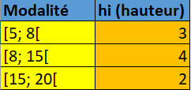
We can therefore see that the histogram associated with the data summarized in the table above has three blocks and that each block is a rectangle, so it has four vertices. However, the blocks are stuck so the rectangles have (at least) two vertices in common (these vertices are located on the abscissa axis, i.e. they have an ordinate equal to zero)
Indeed, we can see that there are ten peaks. On the other hand, it is obvious that the x-axis of the peaks are associated with the bounds of the intervals/classes and that the ordinates of the latter are associated with the heights. Moreover, the first two peaks of the first block have as abscissa the lower bound of the first class (or the ordinate of the first peak is 0 and the ordinate of the second peak is equal to the height of the first class) On the other hand, the last two points of the last block have as abscissa the upper bound of the last class (or the ordinate of the penultimate peak is equal to the height of the last class and the ordinate of the last peak is 0)
Based on the previous remarks we start by creating the first column (that of the abscissas of the peaks) by repeating twice the value of the lower bound of the first class, three times the value of each intermediate bound, and twice the value of the upper bound of the last class.
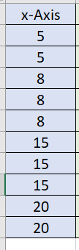

Then, we start by integrating in a second column the ordinate associated with each abscissa. In particular, we give the value 0 for the first cell and the height of the first class for the second cell. Then we give the value of the height of the last class to the second last cell and the value 0 to the last cell
x-Axis | Y-Axis
5 | 0
5 | 3
8
8
8
15
15
15
20 | 2
20 | 0
For the values that are repeated three times in the abscissa column (which correspond to the intermediate limits) we give the following successive values to the cells (of the ordinates) in order:

- The height of the class where the intermediate value is an upper bound
- Zero
- The height of the class where the intermediate value is a lower bound

X-Axis | Y-Axis
5 | 0
5 | 3
8 | 3
8 | 0
8 | 4
15 | 4
15 | 0
15 | 2
20 | 2
20 | 0

Select these two columns Click on the part to select the "recommended graphics" graphs (you will find the Scatter directly)

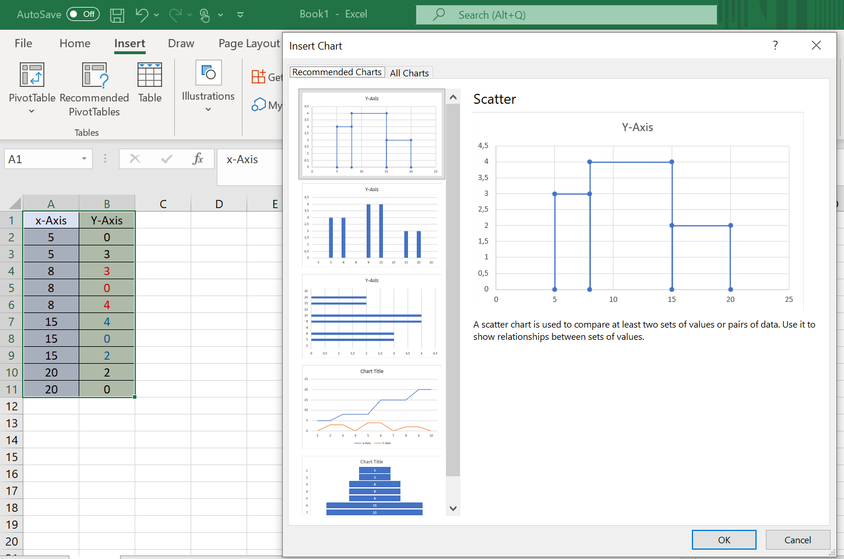

Explore chart options for better formatting (title/colors/labels/...)

The curve of increasing cumulative frequencies (associated with a discrete variable)

Remember that when the data are from a discrete variable the curve is stepped. EXCEL does not allow you to construct this curve directly. There are several possible tricks to build such a graph.

In the rest of this section, we will detail a particular trick that allows us to construct this curve of increasing cumulative frequency. In fact, the method we will discuss in this section is based on the creation of two columns that contain the abscissa and ordinate of all the points that make up the "steps". Note that these columns must respect the order of appearance of the points (from left to right / from bottom to top)
To illustrate this method we will use the following example.
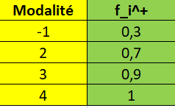
To constitute the column of x-axis, it is enough to duplicate each modality twice in a new column.

X-Axis | Y-Axis
-1
-1
2
2
3
3
4
4

Start by giving the value of 0 and the value 1 respectively to the ordinates of the first and last point.

X-Axis | Y-Axis
-1 | 0
-1
2
2
3
3
4
4 | 1

For the remaining boxes repeat twice and in order the values of the column of increasing cumulative frequencies

x-Axis | Y-Axis
-1 | 0
-1 | 0,3
2 | 0,3
2 | 0,7
3 | 0,7
3 | 0,9
4 | 0,9
4 | 1

Select these two columns Click on the part to select the "recommended graphics" graphs (you will find the Scatter directly)

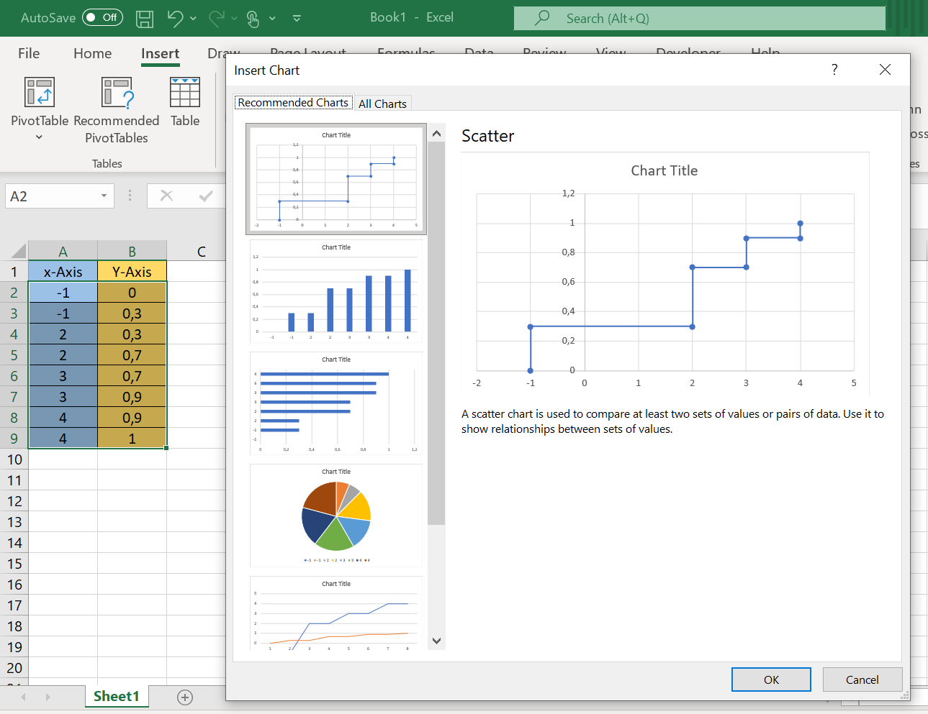

Click on the vertical lines that connect the "steps" to get the formatting line (in particular, you can turn these lines into dotted lines and change the color)

Explore chart options for better formatting (title/colors/labels/...)

The curve of increasing cumulative frequencies (associated with a continuous variable)

Start by creating a column with the boundaries of the classes (respecting the ascending order of the values)
Create a second column where you associate to the first value of the previous column (the smallest limit) the number 0 and for the other limits please associate the values of the increasing cumulative frequencies (respecting the order)

Select the values of the last column and click on the part allowing to select the graphs « Insert Line or Area Chart » Choose « 2D-Line »

By default, Excel will number the abscissa: 1, 2, 3, ... If these numbers (by default) do not correspond to the modalities of the studied variable (i.e. the limits of the classes), then they must be modified by following these steps:
      - Click on "The funnel" located to the right of the graph and then on "select data"
- In the "labels of the horizontal axis" section, click on modify and then assign to the abscissa the range that corresponds to the modalities of the variable studied (in this case, the classes)

To add an arrow to the axes (just double click on the graph to get to the area dedicated to the formatting. Then select the axis you wish to modify in the "Format Axis" menu and then choose your options (color / thickness / type of final arrow /...)
Explore the chart options for better formatting (title / colors / labels / ...)

